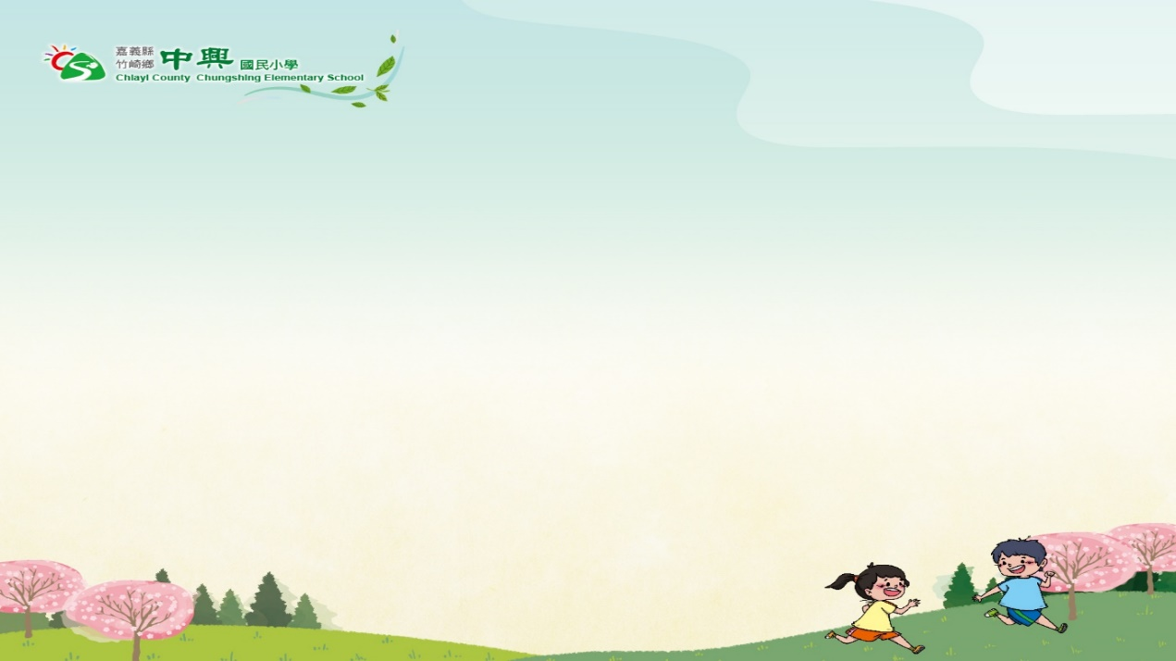

Chung-Shing Primary School (CSES)

Cultural Exchange Program
To Parul Jain,

It is with pleasure that I submit this formal proposal of interest for the Cultural Exchange Program made by the Ministry of Education, Taiwan, in order to collaborate with English-Speaking countries for the purpose of international education.

This Cultural Exchange Program for English-Speaking Countries consists of the overview of the CKPS demographics, school profile, course features, and the ultimate prospective of signing a Memorandum of Understanding (MOU).

We look forward to working with your prestigious school. Your kind response will be highly appreciated. Thank you for your consideration.

Sincerely Yours,
Chen-Fu, Tseng (Bruce)

https://www.cses.cyc.edu.tw/
No.10-1, Shizhuo, Zhuqi Township, Chiayi County 604, Taiwan bruce780117@gmail.com
P｜ +886-5-2561021
F｜ +886-5-2562230

A. School Profile
Founded in 1969, Chung-Shing Primary School (CSES) is located in No.10-1, Shizhuo, Zhuqi Township, Chiayi County 604, Taiwan(https://goo.gl/maps/HpTtzkRDVwsD6wD48), This year marks the school's 55th anniversary celebration, in the name of its Chinese Mandarin meaning “Revival, vitality, and growth.” (Chung-Shing). The school is located in the Alishan area at an elevation of 1,400 meters. Currently, CSES has six classes and 29 students. The students include Taiwanese, Hokkien, Indigenous, and new immigrant backgrounds, with their family roots originating from Malaysia, Mauritius, Singapore, Vietnam, and China. As a result, students possess diverse cultural backgrounds, which facilitate the cultivation of cross-cultural awareness, further enhancing their uniqueness and making them advantageous in global cooperation and competitiveness. CSES has seized the chance to devote the best teaching resources and efforts to educate the students in a sense of cultural understanding as well as social justice, and guarantee them a safe and sound learning environment.

School Name | Chung-Shing Primary School (CSES)
School Type | Special Remote School
Composition of Students | Coeducation
Student Number | 29
Range of Age | 7-12
Student Diversity | Taiwanese, Malaysia, Mauritius, Singapore, Vietnam, China, and indigenous (Tsou).
The Main Instruction Languages | Mandarin and English
School Address | No.10-1, Shizhuo, Zhuqi Township, Chiayi County 604, Taiwan

B. School Features
CSES is dedicated to school-based curriculum development and diversified planning, with the aim of inspiring greater learning motivation and vitality among children in mountainous areas. The content of curriculum development includes local tea culture, scientific exploration, reading courses, international education, and music and arts, allowing students to learn in real-life contexts and connect with the world.

Promote international education in an all-round way, from the downward extension of English teaching, the increase of English learning hours, the international campus environment, the immersive English learning experience, the promotion of international cultural courses such as the various international exchange projects on iEARN (https://www.iearn.org/), to take a multi-pronged approach to make international education rooted in CSES from localization to globalization.

C. Expected Collaboration Module
We’re familiar with the ICT learning approaches. Our expected collaboration modules are included but not limited to:
1. International Companions for Learning –ICL
2. International Education and Resource Network-Learn

D. Special Requirements
We are flexible to cooperate with countries with a time difference. We are also capable of using various online meeting programs for our collaborative learning, including Google Meet, Skype, Cisco Webex, etc.

F. Contact Window
Bruce (Chen-Fu) Tseng
English Teacher
bruce780117@gmail.com
P｜ +886-5-2561021
F｜ +886-5-2562230

G. Website References
CSES School Website | https://www.cses.cyc.edu.tw/
CSES Facebook | https://www.facebook.com/ChiayiCountyChungShing/

